# **Company Management in Textile PLM Digitalisation**

## **1. Introduction**

This document presents the latest **Textile PLM Digitalisation** project updates, focusing on the **Company Management** feature. The newly implemented features allow the admin to manage companies dynamically, which includes adding, editing, and deleting companies. This feature is essential for keeping the system updated with accurate data and ensuring that the correct companies are associated with orders, thus enhancing business reporting and operational efficiency.

Previously, company management was a manual process. With the latest improvements, the system now provides automated management within the admin dashboard, leading to improved flexibility and reduced errors.

The recent changes to the **OrderManagement.tsx** file enable company creation while processing orders, ensuring the system is adaptable and capable of handling dynamic business requirements.

## **2. Key Features of Company Management**

### **2.1 Overview of Admin Capabilities**

The **Admin Dashboard** provides a comprehensive interface for managing company data. The main functionalities available to the admin are:

* **Adding New Companies**: Admins can dynamically add companies if they aren't listed in the system.
* **Editing Company Information**: Company details can be updated, such as name, address, or other company-related metadata.
* **Deleting Companies**: If a company is no longer needed, admins can delete it from the system to maintain data cleanliness.

These features empower the admin to maintain an updated and organized database, improving business operations and order processing.

### 

### **2.2 Dynamic Company List for Orders**

In addition to managing company data, the system allows admins to select and associate companies with orders dynamically:

* **Company Dropdown List**: Admins can select from a list of pre-existing companies when creating or editing orders.
* **New Company Addition**: If a company is not on the list, the admin can add it during order creation, ensuring no interruptions in processing.

This dynamic company list updates in real-time, providing admins with flexibility and up-to-date options when processing orders.

### **Example:**

Imagine that **ABC Textiles** recently became a new supplier. While creating an order for this company, the admin realizes that it’s not listed. The admin can directly add **ABC Textiles** to the system during order creation. The company will then be available for future orders, reducing the manual process.

## **3. Detailed Workflow of Company Management**

### **3.1 Adding a New Company**

Admins can easily add a new company if the required one is missing from the system. The process includes the following steps:

1. **Navigation**: The admin navigates to the **Company Management** section in the dashboard.
2. **Form Input**: A form is provided where the admin enters essential details, such as the company name, address, and other relevant information.
3. **Validation**: The system ensures that the company name is valid (e.g., no empty fields or invalid characters).
4. **Submission**: After form submission, the company is immediately added to the system and available for selection in future orders.
5. **Confirmation**: A confirmation message is displayed to the admin to confirm the successful addition of the company.

This seamless process ensures that new companies can be added without any downtime, facilitating real-time business operations.

### 

### **Example:**

An admin is adding a new supplier, **Global Fabrics**. They navigate to the company section, input the required information (company name, contact details, etc.), and submit the form. The system validates the input and confirms the new entry with a success message. **Global Fabrics** is now available for order processing.

### **3.2 Editing Existing Companies**

Admins can also edit company information when needed. For example, if the company’s address changes or the name is updated, admins can:

* **Select the Company**: Navigate to the company in the list.
* **Update the Form**: Modify the necessary fields in the company information form.
* **Submit the Changes**: After submission, the updated company information will be reflected in the system.

By allowing edits, the system ensures that company information is always accurate.

### **3.3 Deleting a Company**

If a company is no longer relevant, the admin can delete it:

1. **Selection**: The admin selects the company to delete.
2. **Confirmation**: A confirmation prompt appears, ensuring that the deletion is intentional.
3. **Deletion**: Upon confirmation, the company is removed from the system and no longer available for association with orders.

Deleting companies helps keep the system organized and removes unnecessary data.

## **4. Technical Implementation**

### **4.1 Frontend Implementation**

In the **OrderManagement.tsx** file, several frontend changes were made to facilitate company management:

* **New Input Fields**: A form was added for admins to input and update company data.
* **Dropdown Selection**: A dynamic dropdown list allows admins to select existing companies or add new ones in real-time.
* **Validation Logic**: JavaScript validation was added to ensure correct input, such as preventing empty fields or invalid characters before submission.

This allows a seamless experience for the admin, ensuring that company management is both intuitive and flexible.

### **4.2 Backend Implementation**

The backend was updated to support the company management features:

* **API Endpoints**: New API routes were created to handle the addition, editing, and deletion of companies.
* **Database Schema**: The MongoDB schema was modified to store and retrieve company data, ensuring proper association with orders.
* **Validation**: The system uses backend validation to ensure that only valid company names and information are stored.

### **4.3 Security Implementation**

The company management module is restricted to authorized admin users. Only authenticated users with proper credentials can access these features. The system employs **Role-Based Access Control (RBAC)** to ensure that only admins can manage companies and order associations.

By implementing strict security controls, the system guarantees data integrity and prevents unauthorized access to sensitive company and order information.

## 

## 

## 

## 

## 

## 

## 

## **5. Use Case Diagram: Company Management**

The following diagram illustrates the interactions within the **Company Management** system, specifically focusing on the admin's ability to manage companies, products, and users, with validations for company names during the process.

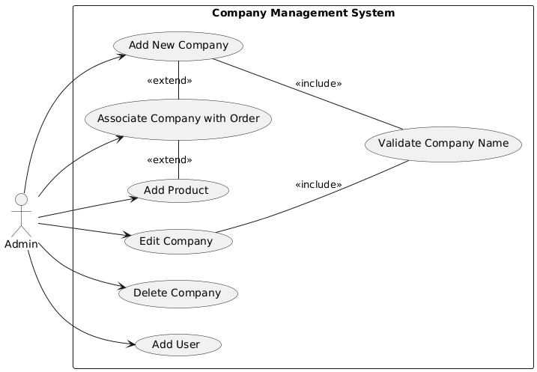

### **Use Case Description**

* **Actor**: Admin
  + The admin is responsible for managing all aspects of the company, products, and user data.
* **Use Cases**:
  + **Add New Company**: The admin can add a new company to the system. This process includes an extension point where the system validates the company name to ensure correctness and uniqueness.
  + **Edit Company**: The admin can edit existing company details, such as the company name, address, and associated metadata.
  + **Delete Company**: The admin can remove a company from the system if it is no longer needed. This keeps the database organized and up to date.
  + **Associate Company with Order**: When processing an order, the admin can associate it with an existing company or add a new one if needed. This ensures accurate reporting and order tracking.
  + **Add Product**: The admin can add new products under specific companies, enhancing the company's inventory or product listing.
  + **Add User**: The admin has the authority to add new users to the system, ensuring the appropriate personnel have access to the company's data.
* **Extension Points**:
  + **Validate Company Name**: Both the "Add New Company" and "Edit Company" use cases extend the validation feature. This ensures that the company name is unique, correctly formatted, and free from invalid characters.
* **System Boundary**: All the features and functionalities of the **Company Management** system are restricted to authenticated admin users, ensuring that only authorized personnel have the ability to manipulate company and order data.

This diagram outlines the core interactions between the admin and the system for managing companies, products, users, and orders. It highlights how validation is an integral part of both adding and editing companies, ensuring data consistency across the platform.

## 

## **6. Conclusion**

The implementation of the **Company Management** module in the **Textile PLM Digitalisation** project has introduced significant improvements to the system. Admins can now dynamically manage company data, ensuring that the system is always up-to-date and capable of handling new business requirements. The ability to add, edit, and delete companies directly from the admin dashboard provides enhanced flexibility and streamlines the order management process.

These updates have significantly improved the functionality of the system, allowing for better business operations and more accurate reporting. The addition of robust security measures ensures that only authorized users have access to these critical features, further enhancing the system's reliability.